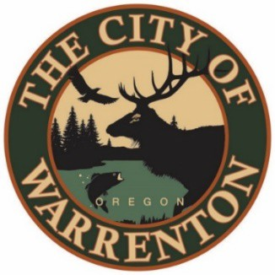

AGENDA

MARINA ADVISORY COMMITTEE
November 20, 2023 at 2pm
Warrenton City Commission Chambers – 225 S Main Ave
Warrenton, OR 97146

Public Meetings will also be audio and video live streamed. Go to https://www.ci.warrenton.or.us/administration/page/live-stream-public-meetings for connection instructions.

CALL TO ORDER

PUBLIC COMMENTS

CONSENT CALENDAR

Meeting Minutes November 2023

OLD BUSINESS ITEMS

Update on Budget FY 2023-2024

Update on Hammond Bank Stabilization

NEW BUSINESS ITEMS

Report from Don Beck Interim Harbormaster – Maintenance Updates

DISCUSSION ITEMS

Marina’s Proposed RV Park

Volunteer Cleanup Plan

COMMITTEE COMMENTS

ADJOURNMENT

Warrenton City Hall is accessible to the disabled. An interpreter for the hearing impaired may be requested under the terms of ORS 192.630 by contacting Dawne Shaw, City Recorder at (503) 861-2233 at least 48 hours in advance of the meeting so appropriate assistance can be provided.

