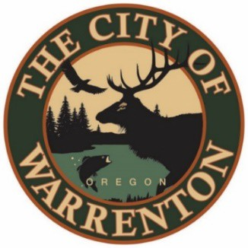

AGENDA

MARINA ADVISORY COMMITTEE
January 22, 2024 at 2pm
Warrenton City Commission Chambers – 225 S Main Ave
Warrenton, OR 97146

Public Meetings will also be audio and video live streamed. Go to https://www.ci.warrenton.or.us/administration/page/live-stream-public-meetings for connection instructions.

CALL TO ORDER

PUBLIC COMMENTS

CONSENT CALENDAR

Meeting Minutes December 2023

OLD BUSINESS ITEMS

Update on Budget FY 2023-2024

NEW BUSINESS ITEMS

Officer Elections

Report from Don Beck Interim Harbormaster – Maintenance Updates & 2023 Accomplishments

Warrenton E Dock Piles & Long-Term Plans for E Dock

Seafarer’s Park King Tide Damage

DISCUSSION ITEMS

Volunteer Cleanup Plan

COMMITTEE COMMENTS

ADJOURNMENT

Warrenton City Hall is accessible to the disabled. An interpreter for the hearing impaired may be requested under the terms of ORS 192.630 by contacting Dawne Shaw, City Recorder at (503) 861-2233 at least 48 hours in advance of the meeting so appropriate assistance can be provided.

