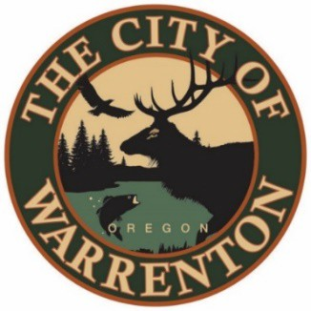

AGENDA

MARINA ADVISORY COMMITTEE
February 26, 2024 at 2pm
Warrenton City Commission Chambers – 225 S Main Ave
Warrenton, OR 97146

Public Meetings will also be audio and video live streamed. Go to https://www.ci.warrenton.or.us/administration/page/live-stream-public-meetings for connection instructions.

CALL TO ORDER

PUBLIC COMMENTS

CONSENT CALENDAR

Meeting Minutes January 2024

Harbormaster Report

OLD BUSINESS ITEMS

Warrenton and Hammond Campground – Seth Hague & Mark Tolley

NEW BUSINESS ITEMS

Marina Presentation – City Manager Esther Moberg & Interim Harbormaster Don Beck

Capital Improvements FY 2024-2025 – Interim Harbormaster Don Beck

DISCUSSION ITEMS

Constituent Suggestions – Chair Lylla Gaebel

GOOD OF THE ORDER

ADJOURNMENT

Warrenton City Hall is accessible to the disabled. An interpreter for the hearing impaired may be requested under the terms of ORS 192.630 by contacting Dawne Shaw, City Recorder at (503) 861-2233 at least 48 hours in advance of the meeting so appropriate assistance can be provided.

