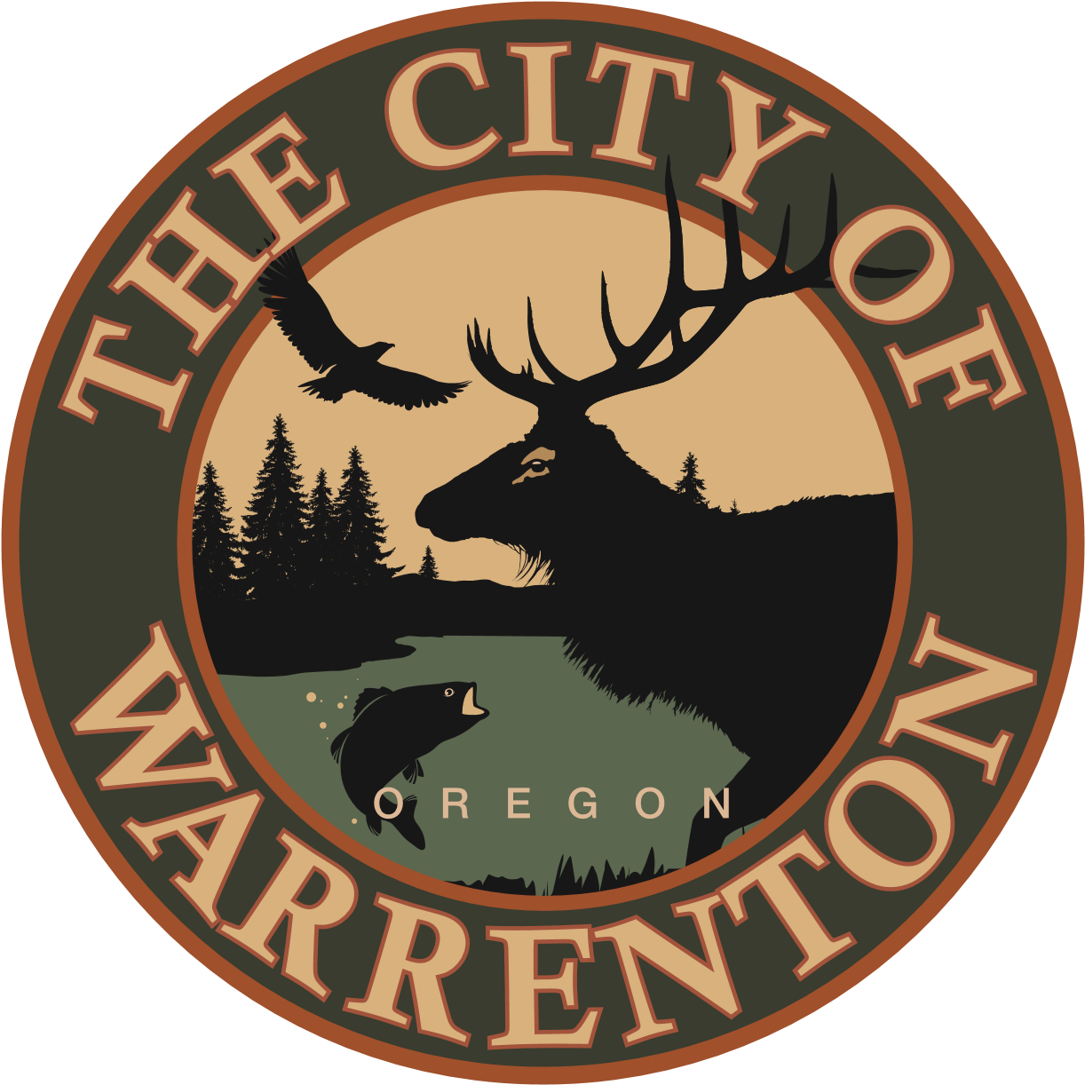 | Memorial Application

Please submit two original applications to the City Manager, City of Warrenton, P.O. Box 250, Warrenton, OR 97146. The City will respond to your request within 30 days. All additional expenses to the City related to this application that are exceptions to the City of Warrenton Parks Memorial Policy must be paid upon approval of this application and prior to beginning the installation process.

Name of Applicant(s)
Mailing Address
Contact Phone Number Alternate Phone Number
I have attached a list of alternate contacts and their address to the back of the application.
I would like a memorial Bench or Tree at the park (choose a City Park or Trail from the list below). Fees for these memorial items are defined in City of Warrenton Resolution 2359 which is attached to this application form. A picture of the approved City Memorial Bench is also attached.
Quincy and Bessie Robinson Park Fort Stevens Parade Grounds Park Seafarers Park
Eben Carruthers Park Dog Park Statue Park
Post Office Park Pacific Drive Linear Park SE 1st St to SE 5th St Trail
Carruthers Park to Enterprise Trail Other No preference
If other, please provide a location
The proposed memorial is:
Please inscribe my bench with the following words
If you are proposing a City approved bench or tree, it is not necessary to complete the questions below. Please sign and date your application and submit it.
Please attach a diagram or drawing of your proposed memorial to the back of this application.
The proposed memorial will benefit
Estimated cost for the memorial Proposed budget year for memorial
Will this project be carried out in phases? Yes No How many phases?
If yes, please include the total cost of the project and years required to complete .
Estimated costs for yearly maintenance of the proposed memorial .
Proposed funding options for maintenance include (Please select from the options listed below). Maintenance funding is not required for City approved benches or trees, but may be required for other proposed memorials.
Volunteer Parks Budget Donations Ongoing trust account
Corporate General Obligation Bond Other

It you selected any option above other than Parks Budget, please include an explanation of the proposed funding, an agreement proposal and/or an explanation of the proposed funding option. Parks Fund availability may determine approval of your proposed project.

Signature Date

Approvals
City Manager ____PW _____ Parks Advisory Board _____ City Commission _____
City Manager_____ Finance _____

